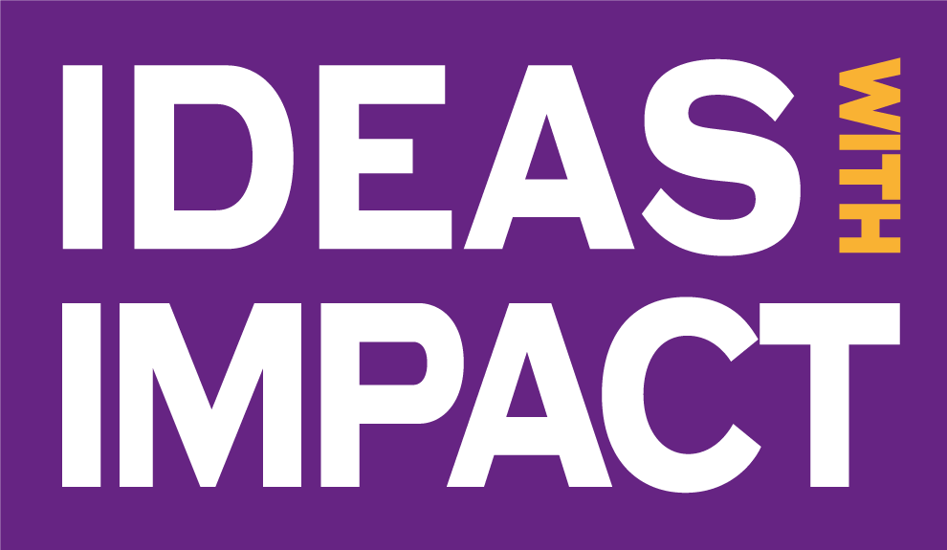

Ideas with Impact Partners Programme
Application Form
Ideas with Impact is looking to select the most inspiring, commercially viable innovations for a unique philanthropic funding programme that will accelerate early stage research projects, allowing them to reach their full potential, globally.
Working with the commercialisation team at the University of Manchester Innovation Factory, we will use the funding to launch your exciting ideas, overcoming the financial obstacles that you may have faced otherwise.
Along with key funding, successful/selected projects will have access to a major support system of industry connections, commercial advice, business-planning workshops, and the all-important network of philanthropists involved.
Do you have a truly fantastic project that could fit in to one of these categories?
• Climate Emergency Solutions
• An Interconnected World
• Healthy Futures
Use the form below to let us know and we will be in touch!
1. Project Name
2. Description of technology/product/service that is being developed. Progress to date.
Summary of the translational research, describing work completed to date. This should give enough detail to understand what the development is and the stage the project has reached. What will make this create future impact and how can this be realised (new business, license to industry etc)?
3. Which Theme does your project fall into?
☐ Climate Emergency Solutions
☐ A Connected World
☐ Healthy Futures

4. The project team – Please highlight primary contact.
Name | Position | Faculty | Department / Institute | Email | Tel

5. Please list any background reading that will help us understand the area of the idea.
Any relevant papers, articles, essential reading etc.
6. How is your project currently being funded and, most importantly, how could additional funding from the Ideas with Impact Partners Programme help you create real world impact
Please include R/P codes where possible.
7. Are you working with any companies, NGO’s, or other external partners on this project?
8. Are there any partners that you would like to work with to drive your project forward?
9. Is what you are doing unique or are there other projects being run to achieve the same outcome/impact?
Why is your project better, more advanced, or more likely to generate a more positive impact?
10. Why would your project appeal to a philanthropic donor? Why is this going to have a positive social, environmental, or economic impact?
11. What is your vision for the future evolution of this project? Please detail the scientific and development road map and key milestones.
12. How much additional funding would you need to achieve your objective and how would it be spent?
13. Will your project generate any new IP?
14. Any other useful information?
Contact Details

Name

Title

Professional Address

Head of Dept/School

CONFIDENTIALITY - The information contained within this Project Evaluation Form will be treated as confidential.

